Ilan Weinschelbaum

Exercise 1:

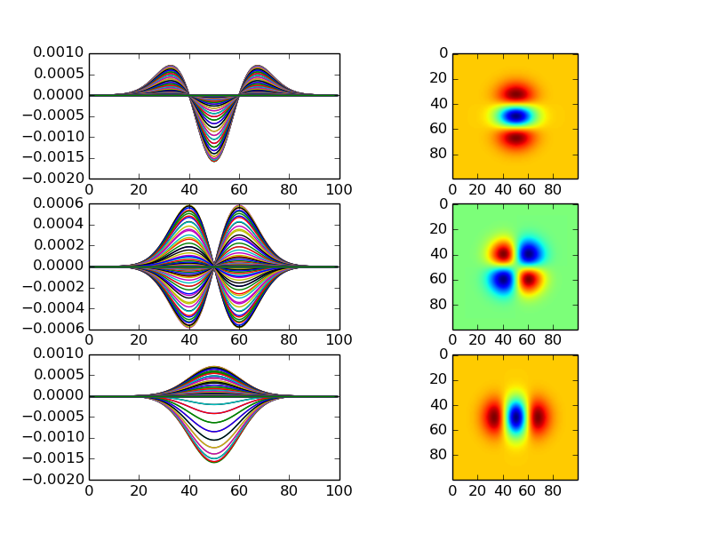

As we can see, these appear exactly as they should. The first is also the same as the second derivative of the 1D Gaussian Kernel, as we would expect. The others show exactly what is expected when taking the other second-order conditions of a 2D Gaussian Kernel.

Exercise 2:

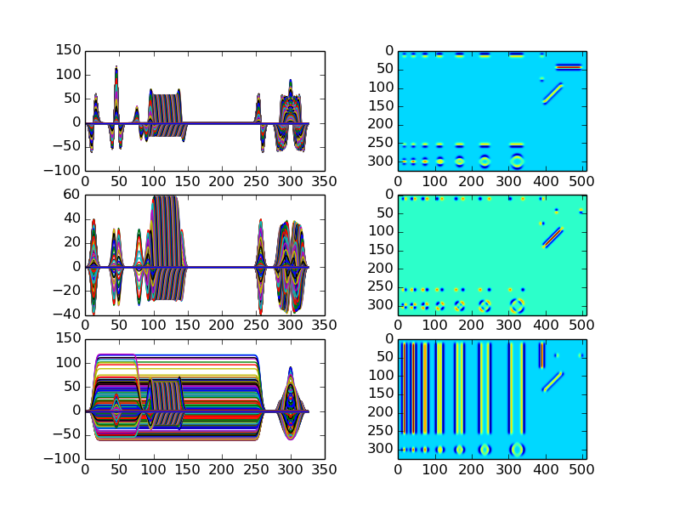

As we can see, in the derivative taken twice with respect to *i*, the vertical stripes appear as a pair of horizontal ones on the edges of the bars. This is because we are evidently taking slices that are parallel to the lines, so Python can only notice the edges of the bars in the perpendicular direction of the slice (i.e. perpendicular to the lines). In the bottom one (derivative taken twice with respect to *j)* we can see that the opposite happens – the slices are perpendicular to the lines, so they detect the longeredges (parallel to the lines, perpendicular to the slice). In the middle case, the derivative is taken once in each direction, so what appears as lines in either the top or bottom cases appears as dots – this is because first the derivative turns them into lines oriented perpendicular to the lines, then parallel, so this leaves a dot. The same is true of the vertical and horizontal line in the corner (for all three cases), which explains why the horizontal line appears in the top case and not the bottom, and the vertical line appears in the bottom but not the top. This is also why the diagonal line appears in all of them – because it is not oriented the same way as any cut, it will always appear in its entirety.

Exercise 3/4:

Unfortunately, I was unable to get the right output. I worked a long time, very hard on it, and was unable to get what was asked. I feel that if we did more practice in Python, I would be better able to code. It is for this exact reason that I am asking again for us to do more actual practice in class. The explanations of the mathematics given in the slides is nice, but not what I (or many people in class) struggle with. I can say that personally, my issue is that I have no coded before, and am still not very familiar with Python’s syntax and commands. If we practiced more in class, I would know more what a typical Python program looks like, which would greatly help in these assignments. Please let me know where my code went wrong, since I can’t find it. Thanks, Ilan